Tyler Wiggins and Vrijesh Patel

This is our own work

CST-247

Bill Hughes

Milestone-1

Link to our GitHub for all our Milestones: <https://github.com/FLAME270/Milestones_for_CST-247.git>

Figure 1:The Burndown chart gives us a visual of all our tasks and helps us manage our time for everything that needs done each week.

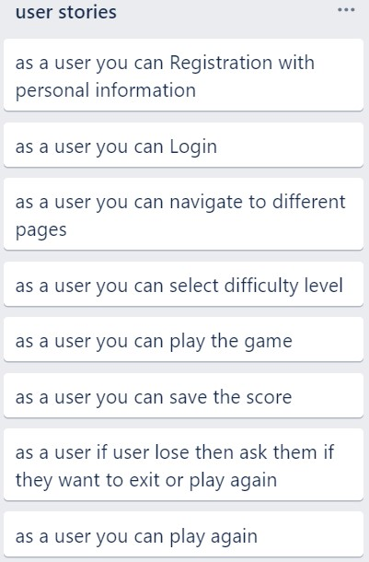

Figure 2: The user story describes all the functionalities that a user can do in our minesweeper application.

Figure 3: Sprint product Log for this Milestone.